Prompt 1:
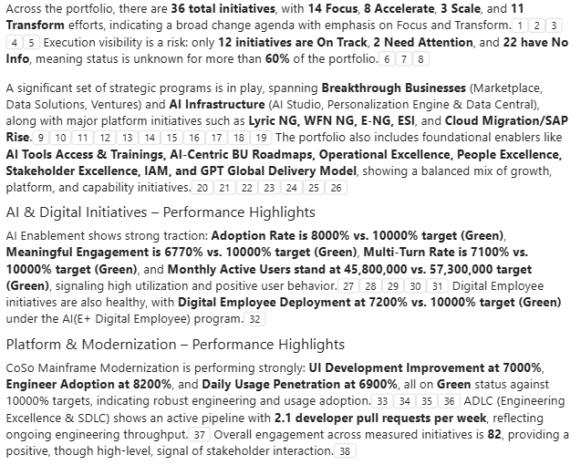

Prompt 2:
Create an email update summary based on this page, please ensure to follow the context below:
1. Ignore any initiative that have a grey status in the progress view.
2. Indicate how many initiatives are in amber or red and point out the associated metrics/KPI's from Metrics view
3. Assume the consumer of this summary is the President of organization who is primarily interested in understanding the initiative health.
4. I am also interested to know initiative health broken down by pillar(Focus, Accelerate, Scale and Transform)
5. When creating the executive summary, also include appropriate metrics/information from the deep dive pages to gain additional insights of the initiative health.
